Curriculum Vitae

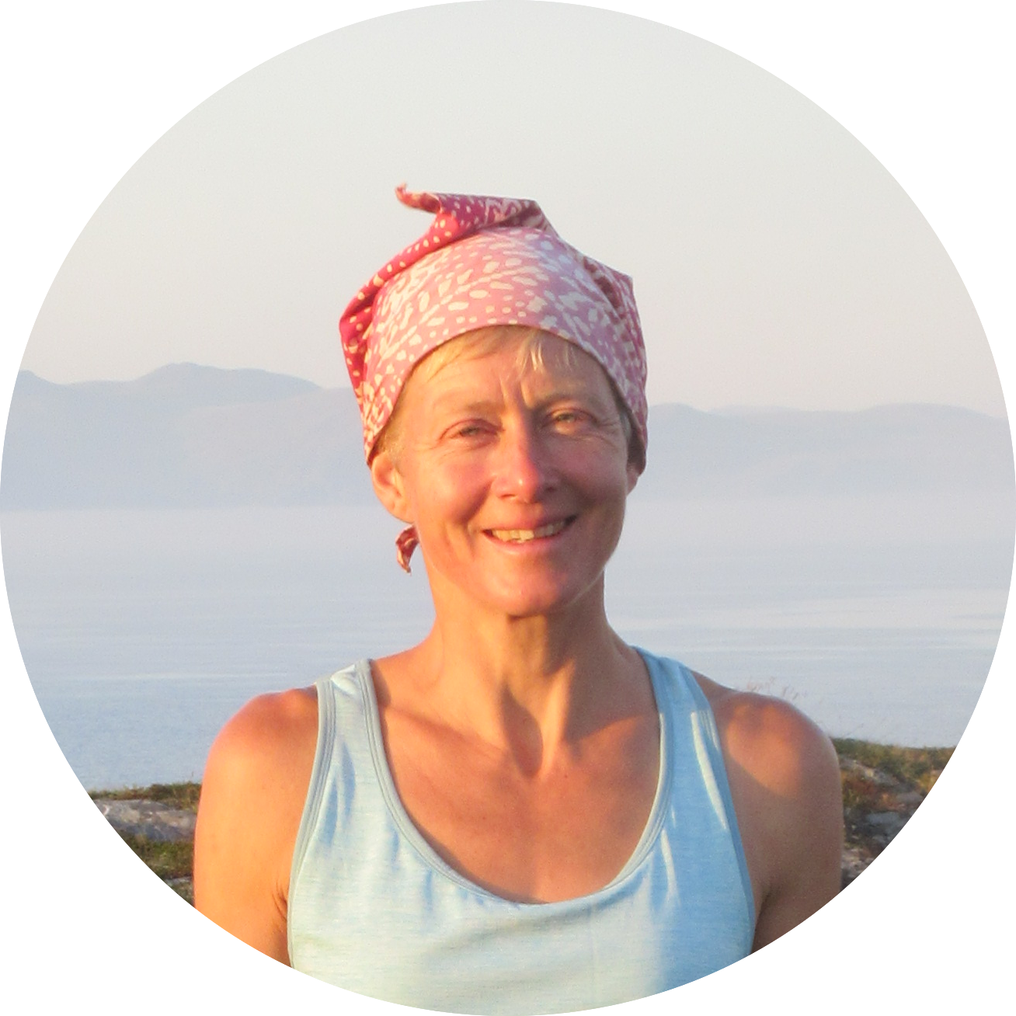

Rebecca Boyd

**Boyd Ecological Survey**

West Brae

Culbokie

Dingwall

IV7 8JU

07977297848 • [becsboyd3@mail.com](mailto:becsboyd3@mail.com)

<https://www.boydecologicalsurvey.com/>

Personal statement

An experienced, conscientious and professional field ecologist with good knowledge of conservation policy and legislation. A highly organised and efficient individual, with a precise approach to projects and extensive experience of data management and report writing.

Key Skills

* Bird, mammal and habitat survey skills
* IT proficiency, data management
* Excellent written and verbal communication
* Project and personnel management
* Protected site management planning
* Presentation, chairing and facilitation
* Media, messaging and interview
* Advocacy and parliamentary experience

Employment History

Freelance ecologist (2012 – Present)

Recent contracts include:

* Wader Survey, Caithness & Sutherland Peatlands SPA (Naturescot)
* Herbivore Impact Assessment, Abriachan, Ledmore & Migdale (Woodland Trust)
* Brown & Shepherd wader and raptor survey, Lochmore, Reay Estate (Galbraith)
* Brown & Shepherd wader, raptor and black grouse survey, Balmac Estate (Galbraith)
* Brown & Shepherd wader, raptor and black grouse survey, Attadale Estate
* Brown & Shepherd wader, raptor and black grouse survey, Gordonbush Estate
* regeneration survey, Abernethy Forest, Cairngorms (CNPA)
* mammal survey, Struy (Scottish Woodlands)
* red squirrel survey, Tore (Galbraith)
* BBS and raptor survey, Loch Ainort (MOWI)
* BBS, black grouse, raptor, badger survey, Conchra Estate
* breeding bird and raptor survey, Auchtertyre (Galbraith)
* upland vegetation survey, Cairngorms (CNPA/ NatureScot)

2003-2011 - Marine Policy and Conservation Officer, Scottish Wildlife Trust

2000-2003 - Freshwater Policy Officer, WWF Scotland

1996-2000 - Area Officer (Skye & Lochalsh) NatureScot (SNH)

1996 - Area Officer (Stirling District) NatureScot (SNH)

1995 - Researcher WWF Scotland Wild Rivers Initiative

Relevant Education

Stirling University

MSc Environmental Management (Distinction)

Oxford University (University College)

D Phil Scottish-Russian relations

Russian & German BA Hons (First Class)

A range of Highers and Advanced Highers, all at A

Relevant Interests

Member of Winston Churchill Memorial Trust Selection Panel for Environment, Conservation and Sustainable Living 2019.

Member of artist team in Iceland working on Northern Exchange creative engagement project 2017

Winston Churchill Fellow 2010/11 working on Place and Community Based Education in the Pacific north-west USA and Canada

Member of team monitoring and researching Pallid Harrier in Kazakhstan

Creative engagement practitioner, experience as a teacher of all age groups

Languages - good Russian and German, French, some Spanish and Gaelic

Rock climbing, sea kayaking, hiking and other sports, music and art. Summer Mountain Leader, Level 3 BCU kayak coach and 5* BCU kayak skills, BSAC Ocean Diver and Sports Diver awards

Expeditions to Andes, Atlas, Rockies, Caucasus, Finnmark, Iceland, Ukraine, Bylot Island, Canadian Arctic

References

References are available on request.